# HR Analytics - Atliq Dashboard 📊

This project is a Power BI dashboard created for analyzing HR data at Atliq Corp. It focuses on key performance indicators related to employee attendance, performance, leaves, and working hours.

## 📁 Project Files

- `HR_Analytics_Atliq.pbix`: Main Power BI dashboard file

- `employee_data.xlsx`: Sample HR data used in the dashboard

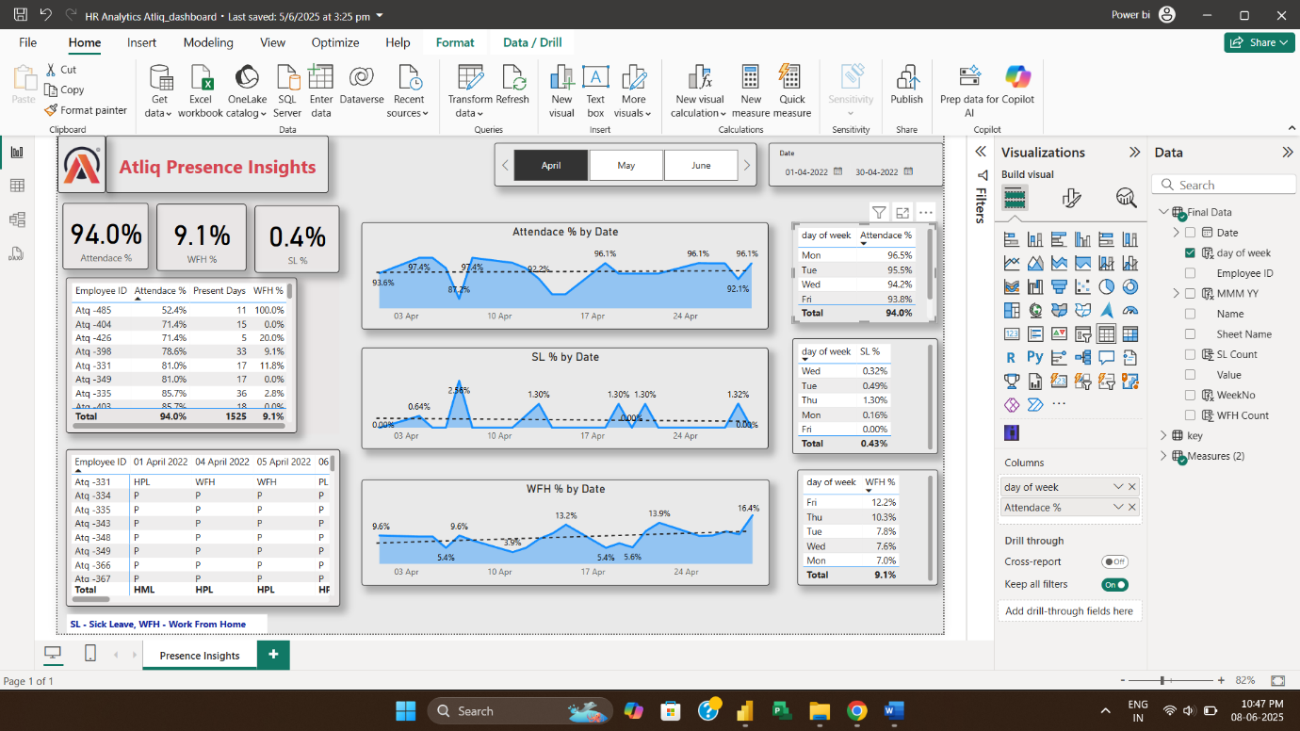- `dashboard_screenshot.png`:

🔍 Key Insights

- Employee Attendance Trends

- Performance Tracking by Department

- Leave Analysis Over Time

- Work Hour Patterns

🛠 Tools Used

- Power BI – Dashboard creation and visualizations

- Excel – Data cleaning and formatting

📌 Features

- Dynamic filtering using slicers

- Clean and modern layout

- Designed to save 3-4 hours/day for HR managers

-Shubham Sarlu